The Peasants’ Revolt

Student: ………………………..…………..…..…..…………… Class: …..…….....………. Due date: …..…….…………………...

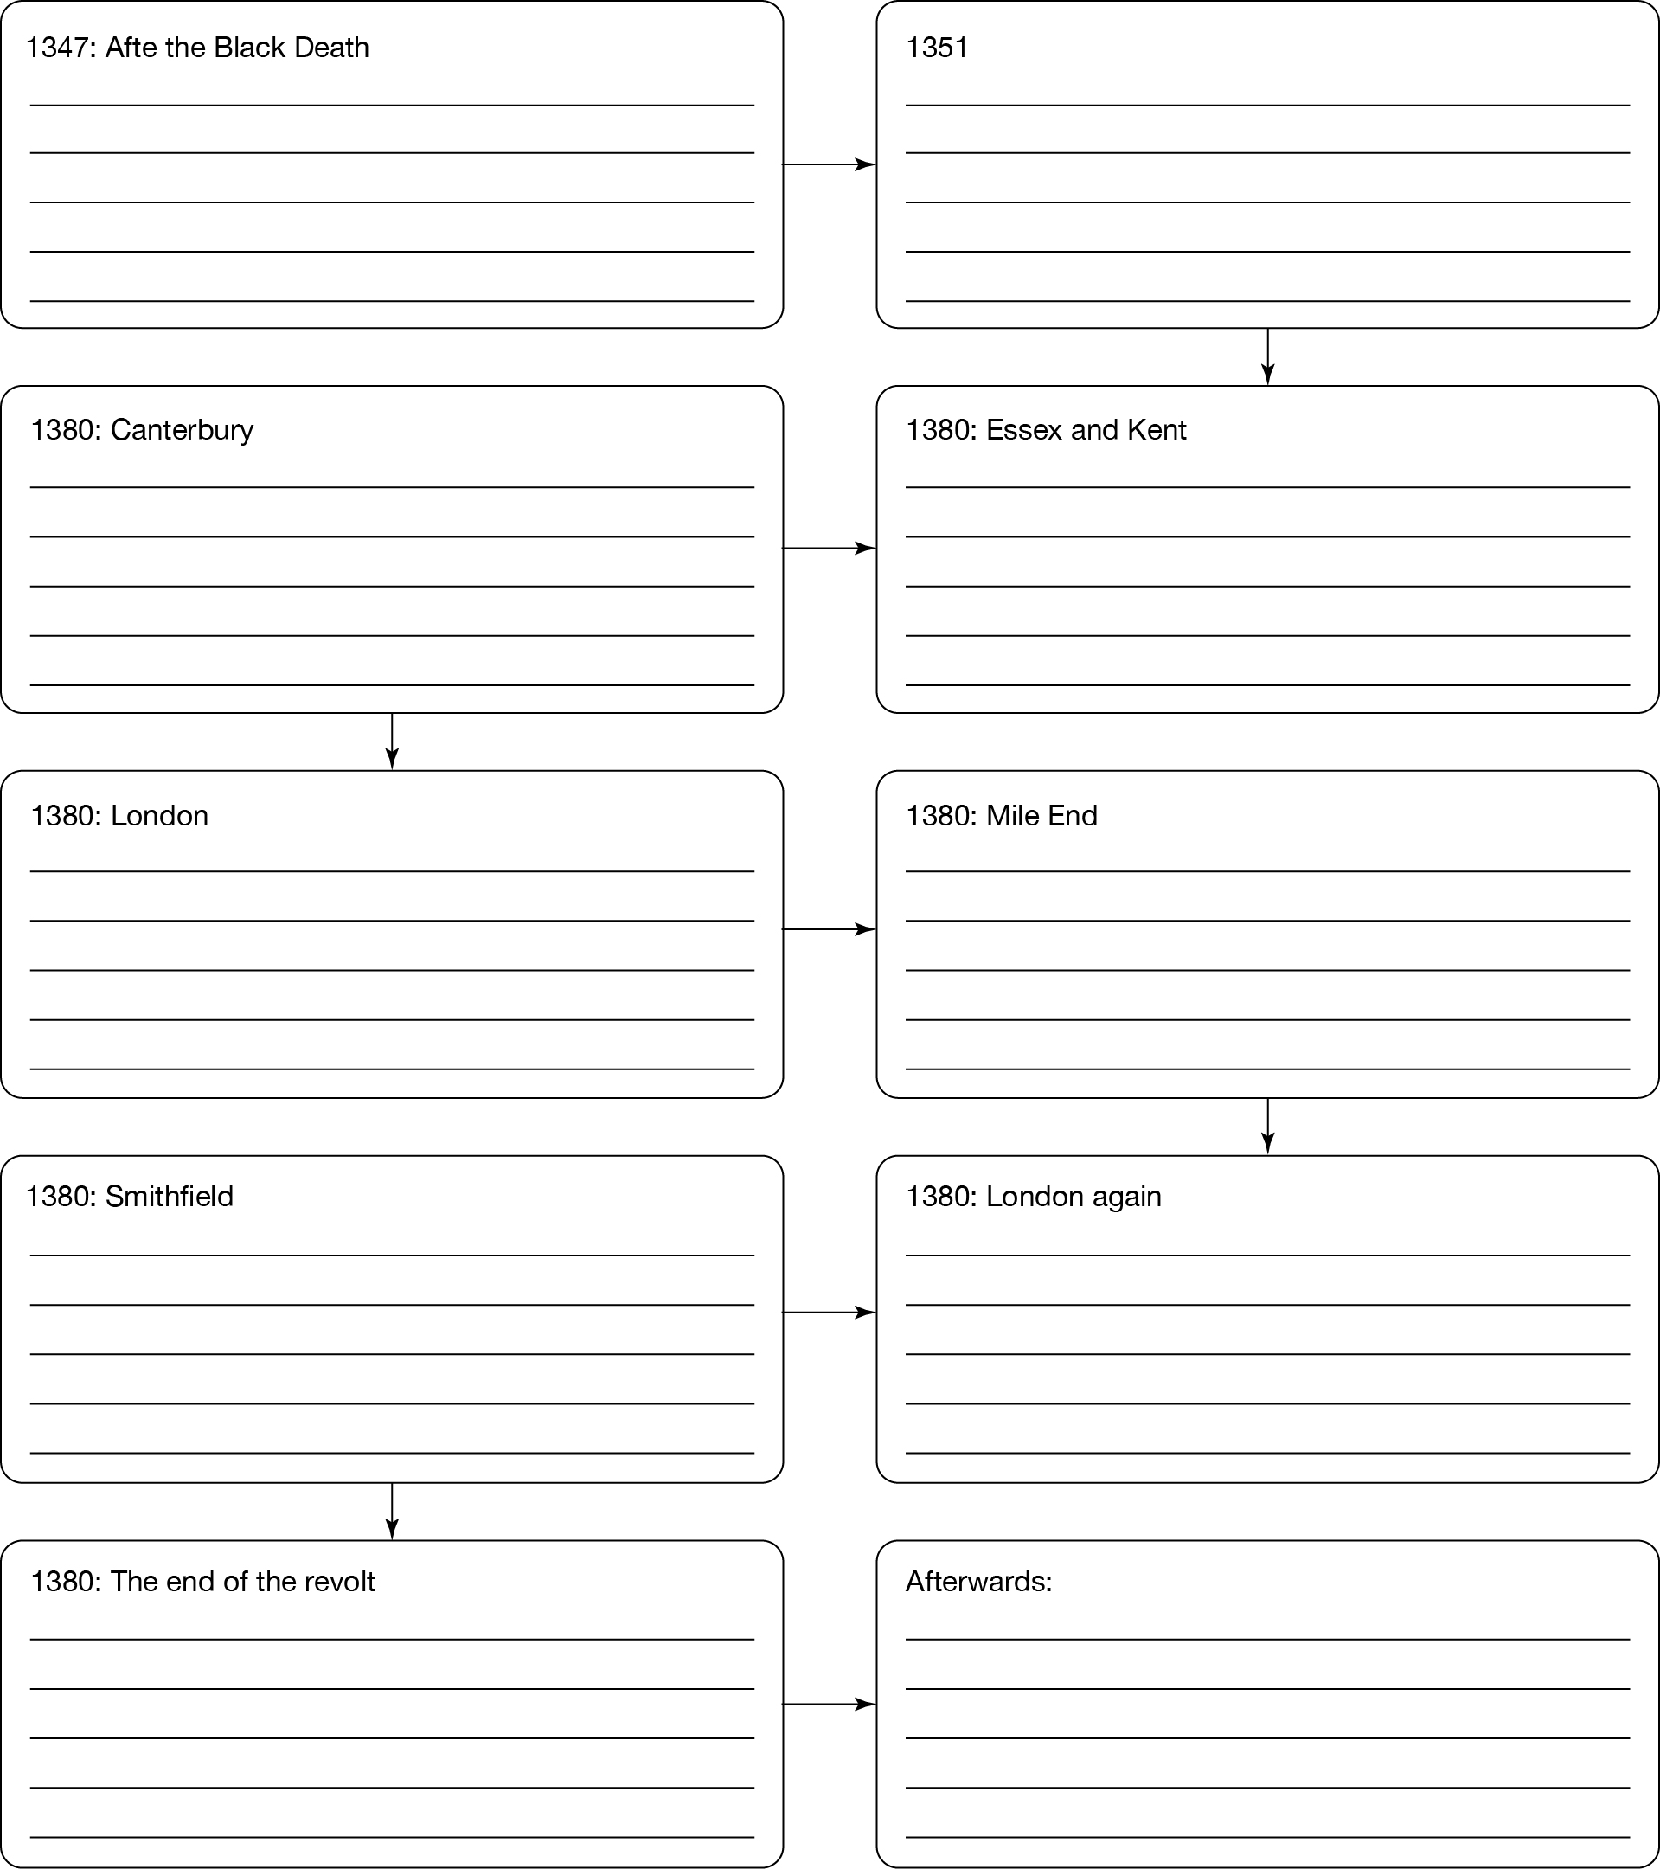A flowchart is a thinking tool that helps us show how one event can lead to another. Complete the flowchart below to summarise the causes and development of the Peasants’ Revolt that took place in the later Middle Ages.